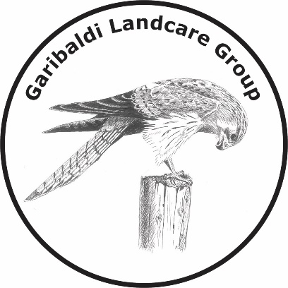
Meeting Dates 2018
(Wednesdays 7:30 pm at Garibaldi Hall)
21st March
16th May
18th July
19th September
21st November (AGM)

ACTIVITY DATES 2018
(Sundays at various places & times TBA)
18th February
15th April
22nd July (National Tree Day Planting)
19th August
21st October
16th December

