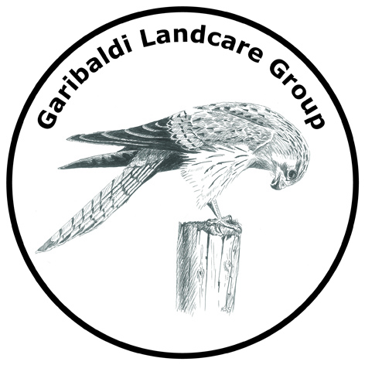

Who are we?

Currently we have approx. 20 members, most of whom live around the Garibaldi area, from Buninyong through to Grenville (and a few from Ballarat)
We are all volunteers. Our committee, elected at our AGM in November, consists of 5 volunteer members.

We currently look after 3 areas of public land:
- Garibaldi Bridge Reserve
- South Durham Bridge Reserve
- Hardies Hill Reserve

What we are doing this year?

- Direct seeding of wildflowers and understorey plants in South Durham Bridge Reserve and Garibaldi Bridge Reserve
- Weed control across all 3 reserves targeting gorse, blackberries, hemlock and herbaceous weeds.
- National tree day at South Durham Bridge, approx. 600 tubestock and 1000 direct seed

What’s in it for you?

- Put your name on part of a reserve if you do the work.
- Access to free seeds and tubestock at cost price.
- Workshops including speakers/hands on activities
- Information about local flora and fauna
- Quarterly Landcare magazine
- Access via Landcare and Leigh Catchment Group for funding and resources for your own property.
- Networking within your local community

How do we work?

- Structured working bees such as National Tree Day and 1st Sunday of each month – determined by our committee
- Ongoing project maintenance is carried out by members on an ad hoc basis individually or in small groups.
- This year we also plan to trial direct seeding in 2 of the reserves, with individuals taking responsibility for each ‘plot’ at a time that suits them.

If you are not a member already, please see attached info on how to join.

